**Factors Contributing to the Increase in Popularity of Irish Rail Network Use**

|  |  |
| --- | --- |
| *Student Full Name* | Raushan Abenova |
| *Student Number* | 2024338 |
| *Module Title* | Strategic Thinking (HDip in Data Analytics for Business) |
| *Assessment Title* | CA 2 – Capstone Project Proposal |
| *Assessment Due Date* |  |
| *Date of Submission* | 12 December 2024 |

**Declaration**

By submitting this assessment, I confirm that I have read the CCT policy on academic misconduct and understand the implications of submitting work that is not my own or does not appropriately reference material taken from a third party or other source.

I declare it to be my own work and that all material from third parties has been appropriately referenced.

I further confirm that this work has not previously been submitted for assessment by myself or someone else in CCT College Dublin or any other higher education institution.

Table of Contents

0

Introduction 2

Strategic overview of the business problem and Business understanding 3

Business understanding 3

Project plan 4

Evaluation. 9

Conclusion 9

Reference: 10

# 

# Introduction

# It is obvious that passenger transportation worldwide has been doubled by 2000. As the need for travel grows in our increasingly globalized and interconnected world, there is a greater emphasis on developing systems that can meet this rising demand while being efficient and socially and environmentally responsible in connecting people across the globe.

In current circumstances rail transport is the most sustainable solution to meet the global demand for mass transit. However, railways often face competition in a free and globalized market, where passengers have the freedom to choose their preferred mode of transport based on various factors, with cost typically being a dominant consideration. While environmental and personal safety impacts play a significant role in today's travel decisions, railways are not always the most appealing option for passengers. As a result, increasing rail passenger usage requires the development of strategies to make rail travel more attractive to customers. In addition, regular maintenance and improved user-friendly access are essential areas that require significant attention. Despite ongoing population growth and the presence of worldwide branches of global high-tech companies in Ireland, it is notable that, as of 2023, rail transport has not regained the popularity it had in 2019. This is especially surprising considering the widespread use and popularity of rail travel in other European countries.

“Apple also raised how “the slow progress regarding the public infrastructure in Cork is very worrying and hindering Apple growth plans”. The document adds: “The current roads network is not sufficient to enable 6,000 Apple employees on their daily commute and is also a struggle for the residents, the traffic and transport situation being so bad.” (C.Mcquinn, 2024).

Given the points outlined above, the current dataset was selected to analyse the existing situation and explore potential strategies for driving a more positive trend in rail transport in the upcoming period.

# Strategic overview of the business problem and Business understanding

The initial focus on business understanding is essential because it ensures that technical work is aligned with business objectives and prevents data scientists from tackling a problem without a clear understanding of the broader business context.

Having studied for many years in France and Switzerland, I was consistently impressed by how these countries developed such efficient rail networks, even in less populated areas. However, now that I am living in Ireland, I often find myself wondering what the potential obstacles might be that prevent the Irish Rail network from reaching such an advanced level of development.

My motivation is to explore factors such as safety and accessibility in rail travels, and how these elements can contribute to improving the future of rail transportation. Irish Rail has significant potential to become an efficient and competitive mode of transport for Ireland.

# Business understanding

Briefly about business activities and operations Iarnród Éireann (Irish Rail). Ireland's railways originated during the "Railway Mania" of the 1830s and 1840s, with the first railway opening between Dublin and Kingstown (now Dun Laoghaire). In 2022, Irish Rail celebrated its 175th anniversary, marking 175 years at the core of both North Ireland community and Ireland’s railway network. The rail network in Ireland spans around 2,400 km of track and includes 1,501 stations, including five stations in Northern Ireland that are directly served by cross-border services. The national rail network operates three main types of services: InterCity, Commuter, and DART. These service categories share certain sections of the rail lines.

The bellow factors in relation to railways may have an impact on economic activity, the level of safety analysis of the railway system in the European Union region will be given for comparison, but will not be considered extensively in this study. Given all this, the current Capstone Project Proposal is designed for two semesters and will analyse data from the EM-DAT database from 2019 to 2023, and will also use updates to the dataset as they become available.

The following steps will be undertaken using the CRISP-DM methodology, due to its iterative updating data, which facilitates ongoing evaluation and enhancement of the model.

# Project plan

Despite the overall trend of population growth and the establishment of European branches of global high-tech companies in Ireland, it is noteworthy that, as of 2023, the popularity of rail transport has not returned to the levels seen in 2019. According to a Data.cso.ie/table/PEA03, the population in Ireland rose by 98,700 people which was the largest 12-month increase since 2008. There were 149,200 immigrants which was a 17-year high. Additionally, the Government of Ireland is dedicated to enhancing high-capacity public transport, ensuring it is appealing to passengers through improved accessibility. This commitment aims to make public transport a convenient and attractive option for all users.

The dataset suggests that the number of train or public transport users in 2023 has not reached the peak levels of 2019 due to a variety of potential factors. These could probably include:

1. Post-Pandemic Effects:Following the COVID-19 pandemic, many people may have continued to favour private cars for safety and convenience, as concerns about public health and train overcrowding likely persisted. To explore this factor further, I will include a survey conducted by the Carzone Motoring Report below.
2. Work-from-Home Trends: The shift towards remote work, which became more common during the pandemic, may have reduced the need for daily commutes, leading to fewer people using public transport.
3. Service Availability and Reliability: Issues related to the availability, reliability, or accessibility of the public transport system—such as delays, maintenance, or limited routes—could deter passengers from using rail services. This factor will be explored in this and subsequent works.
4. Changes in Population and Demographics: Although the population may be growing, shifts in demographics or changes in urbanization patterns could impact public transport usage, particularly if people are relocating to areas with limited rail connectivity.

The aim of this current work is to explore how factors such as safety and ease of access could influence people's mindset, encouraging them to use and prefer public transport over private cars.

First of all, based on Iarnród Éireann (Irish Rail report for 2023), safety is a top priority and will remain a key focus for the company. The company is dedicated to maintaining a safe railway environment and preventing any harm to the health and safety of customers, employees, and contractors as a result of our operations.

In terms of safety, customers are particularly sensitive to the security of a transportation system. Railways are commonly viewed as one of the safest modes of transport. However, rail accidents do occur, and when they involve fatalities, they tend to be highly publicized and dramatic, garnering extensive media coverage. This can, in turn, generate considerable concern and alarm among passengers. According to the Eurostat (2021), only 5% of the railway accidents are due to train collision although they account for the 80% of the total fatalities. Meanwhile, injuries sustained in have increased by 5% on 2023 figures, up to 62 from 65. However, there is a positive downward trend of a reduction of 18% in the number of incidents per million passenger train journeys, with passenger journeys increasing by almost 29% in 2023 (Iarnród Éireann, Annual Report 2023).

At the same time, by the following the latest Carzone Motoring Report for the first semi-annual 2024 Ireland remains a nation deeply rooted in car culture but **81%** of Irish people opting for cars as their primary mode of commuting over public transport. However, based on the Road Safety Authority (RSA), for 2023 a total of 184 people died in 173 fatal collisions in 2023 compared to 155 deaths in 149 collisions in 2022. Whereas fatal injuries in the rail network for 2023 reached 11 people, in 2022 it was 6, and in 2021 it was 5 tragical results.

Thus, based on this data, using rail transport could offer significant advantages to the residents of Ireland in terms of safety. However, the question of why preferences still lean towards personal transportation remains open.

In this regard, let considers factor such as service availability and reliability within the Irish urban transportation.

The National Transport Authority (NTA) of Ireland defines the criteria for punctuality for intercity and regional routes by defined timetable on time or within 10 minutes of time. For DART, Dublin Commuter and Cork Commuter Routes are defined as on time or within 5 minutes of time.

Regarding the punctuality of train services in European countries, I came across some data for comparison:

|  |  |  |  |  |  |
| --- | --- | --- | --- | --- | --- |
| **Operator** | **Service** | **Year of data** | **Definition of delays** | **Punctuality** | **Data source** |
| **SNCB (Belgium)** | All | 2023 | > 6min | 87.50% | [SNCB annual report 2023](https://www.belgiantrain.be/-/media/corporate/pdfs/sncb_rapport_activite_2023_fr.ashx?v=3ba4f2737ca34e82aec7063a4df269de&la=fr&hash=862ADAECA138C34BFFBAA6168A23EB5496B7ABD2) |
| **NS (NL)** | Intercity/intercity Direct | 2023 | > 5 min | 87.71% | [Open data portal rijdendetreinen](https://www.rijdendetreinen.nl/en/open-data/train-archive#description) |
| **SNCF (France)** | INOUI | 2023 | > 5 min | 76.90% | [ART dashboard](https://opendata.autorite-transports.fr/rapports/266/) |
| **OBB (Austria)** | Long distance services | 2023 | > 5min | 80.30% | [OBB annual report 2023](https://static.web.oebb.at/konzern/ar2023/158/index.html) |
| **DB (Germany)** | Long distance services | 2023 | > 6min | 64.00% | [DB annual report 2023](https://ibir.deutschebahn.com/2023/en/home/) |
| **GWR (UK)** | All | 2023 | > 5min | 84.47% | [Office of Rail and Road, Passenger Rail performance](https://dataportal.orr.gov.uk/statistics/performance/passenger-rail-performance/) |
| **CD (Czech)** | Long distance (and commercial) | 2023 | > 5 min | 67.80% | [CD annual report 2023](https://www.ceskedrahy.cz/sites/default/files/soubory-ke-stazeni/financni-zpravy/annual-report_2023.pdf) |
| **CFR (Romania)** | All | 2023 | no information | 85.00% | [CFR website](https://www.cfrcalatori.ro/comunicate/numarul-calatorilor-transportati-de-cfr-calatori-in-anul-2023-mai-mare-cu-5-fata-de-anul-2022/) |
| **SBB (Switzerland)** | Long distance services | 2023 | > 3 min | 90.10% | [SBB webiste](https://reporting.sbb.ch/punctuality?=&years=1,4,5,6,7&scroll=573.3333129882812&highlighted=1d4459ede956ab3d5b27254d0cb65dcb) |
| **Trenitalia (Italy)** | Medium and long trains mileage | 2023 | > 5 min | 89.10% | [Trenitalia annual report 2023](https://www.trenitalia.com/content/dam/tcom/allegati/trenitalia_2014/informazioni/Relazione_sulla_Qualita_dei_Servizi_2023.pdf) |
| **Italo (Italy)** | All | 2023 | > 5 min | 68.95% | [Italo annual report 2023](https://italospa.italotreno.it/static/upload/qua/quality-report-italo-2023_eng.pdf) |
| **VR (Finland)** | Long distance | 2023 | > 5 min | 85.90% | [VR annual report 2023](https://www.sttinfo.fi/ir-files/69819374/7667/8649/VR-Annual-report-2023-EN.pdf) |
| **Eurostar (UK, FR, BE, NL)** | All | 2023 | > 15 min | 81.53% | [Eurostar's customer charter](https://www.eurostar.com/be-en/customer-charter) |
| **CP (Portugal)** | Long distance | 2022 | > 5 min | 53.00% | [CP annual report 2022](https://www.cp.pt/StaticFiles/Institucional/2_gestao_sustentavel/3_Qualidade/relatorio-qualidade-servico-en.pdf) |
| **DSB (Denmark)** | Long distance and regional | 2023 | > 3 min | 71.70% | [DSB annual report 2023](https://www.dsb.dk/globalassets/arsrapport/2023/annual-report-2023.pdf) |
| **PKP (Poland)** | PKP intercity | 2023 | > 6 min | 72.54% | [Polish Office of Rail Transportation (Urząd Transportu Kolejowego) Annual report on train traffic in Poland (2023)](https://utk.gov.pl/pl/dokumenty-i-formularze/opracowania-urzedu-tran/21210,Punktualnosc-pociagow-pasazerskich-w-2023-r.html?search=9977831491) |
| **SJ (Sweden)** | Long-distance trains | 2023 | > 5min | 72.00% | [SJ annual report 2023](https://www.sj.se/content/dam/externt/dokument/finansiell-info/sjab-ars-och-hallbarhetsredovisning-2023.pdf) |
| **ZSSK (Slovaquia)** | All | 2023 | > 5 min | 79.03% | Communicated by ZSSK (email) |
| **Renfe (Spain)** | Ave | 2023 | > 5 min | 87.00% | [Data communicated by Renfe to Europa press, and confirmed to T&E by RENFE](https://www.europapress.es/economia/transportes-00343/noticia-renfe-defiende-puntualidad-ave-87-cercanias-915-20240630104450.html) |

While, recently, I had the opportunity to travel on the DART, and I also captured an interesting photograph during my journey.

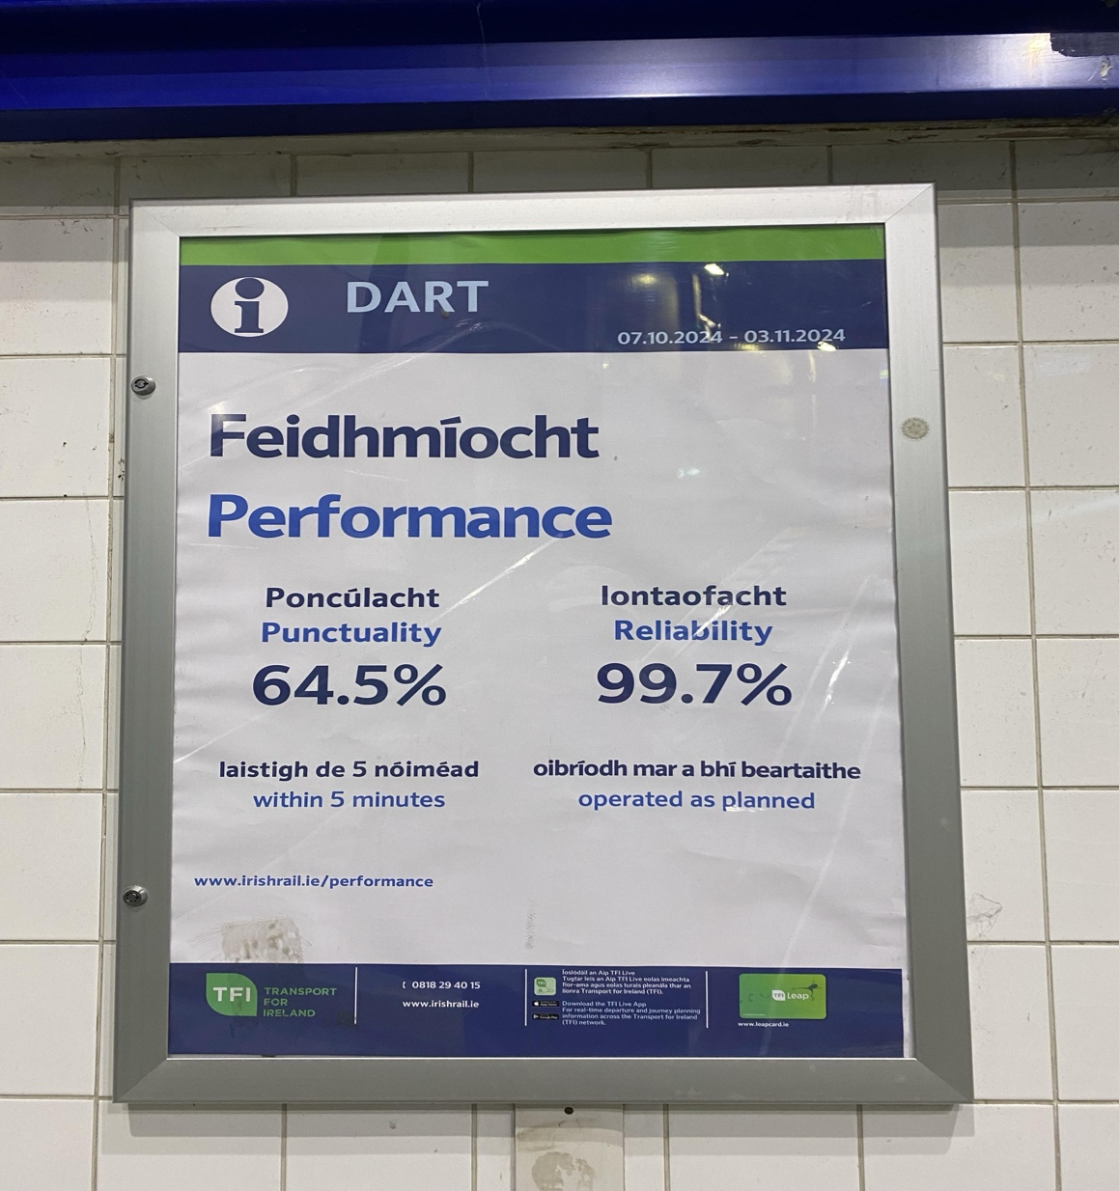

McKinsey, a single global searching partnership, (Report 2024), founds that reliability ranks as the second most important factor for selecting a transport mode by people.

As a result, transport users are becoming increasingly demanding in terms of personal comfort, as well as the efficient use of their time and money when it comes to transportation. In this context, the next step of this work will be to identify how the factors described above and what kind of other features can be improved to positively impact the operational system and contribute to more advanced outcomes for the Irish Rail Company.

# Evaluation.

According to G.Melo (2024), for one or more models that seem to perform adequately, reasonable caution is taken during evaluation to see how well these models will perform on fresh data.

The Data clearly shows that the highest number of journeys occurred in 2019, reaching 50,060, while in 2023, the figure was approximately 46,000. DART remains the most favoured mode of transport among Irish residents, while Dublin suburban services are the least popular.

Customers often have competing objectives and constraints that must be properly balanced. The analyst’s goal is to uncover important factors that could influence the outcome of the project. CRISP-DM understanding. The Data was cleaned using a machine learning technique, such as imputing missing values for features that lacked numerical data and only contained categorical names. For future prediction and accuracy improvements, algorithms like Decision Trees and Random Forest are planned to be used. At the same time, I am optimistic about establishing direct communication with Irish Rail to obtain more detailed information on the data, as well as the latest updates regarding passenger journey numbers.

# Conclusion

As mentioned at the outset of this thesis, modern railways are among the most capacity-efficient, safe, and sustainable modes of passenger transport. These benefits were crucial in enabling railways to become the dominant form of motorized transportation for people in the 20th century. The decline can be attributed to both external and internal factors. Despite the clear competitive factors, railways are also a technically complex transportation system that necessitates significant investments in the construction, operation, and maintenance of tracks and trains. Future work will focus on identifying potential improvements, such as updating operational methods, analysing and integrating data from other European transport companies, and refining the tool to more accurately evaluate its effectiveness.

# Reference:

1. The route to sustainability, Annual Report Irish Rail (December 2022). <https://www.irishrail.ie/Admin/getmedia/aed78e9f-a811-4c3b-a8d4-7609b912e62c/22-IE-Annual-Report-English.pdf>;

2. Transport Hub, Data, CSO.ie (June 2024) <https://www.cso.ie/en/releasesandpublications/hubs/p-transo/transporthub/publictransport/rail/>;

3. Train or Plane ? European Environnement Agency Report (Novembre 2020), page13, <https://www.eea.europa.eu/publications/transport-and-environment-report-2020>;

4. Cormas McQuinn (2024). Apple warned Minister of “treat to Ireland”. Published in article in The Irish Times, September 12, 2024. Page 1, page 12 (<https://www.irishtimes.com/politics/2024/09/12/apple-warned-government-of-real-threat-to-ireland-from-countries-trying-to-lure-multinationals-away/>);

5. Z. Tomes (2006). Long-term structural decline of railways. Masaryk University Brno. <http://www.itregep.cz/media/65214/long_term_decline.pdf>;

6. Data.cso.ie/table/PEA03, CSO statistical publication, 27 August 2024, *Online ISSN: 2009-5226.<https://www.cso.ie/en/releasesandpublications/ep/p-pme/populationandmigrationestimatesapril2024/keyfindings/>*;

7. Joanne Whelan, Joe Sullivan, Billy Gilpin (2023). Customer Safety and Security Report.<https://www.irishrail.ie/getmedia/dfce3645-5928-408b-a9b9-aa76c853c6b3/23-Q2-Customer-Safety-and-Security-Report_Final.pdf>;

8.Road Deaths in 2023 Increase by 19%. <https://www.rsa.ie/news-events/news/details/2024/01/01/road-deaths-in-2023-increase-by-19>;

9. G. [Melo](https://medium.com/@gcesarmelo7?source=post_page---byline--17b43ee3f1b9--------------------------------) (10th September 2024).CRISP-DM: A comprehensive guide to the structured Data Science methodology and its modern challenges. <https://medium.com/@gcesarmelo7/crisp-dm-a-comprehensive-guide-to-the-structured-data-science-methodology-and-its-modern-17b43ee3f1b9>;

10. Train Punctuality and Reliability Performance (2023). <https://www.irishrail.ie/en-ie/about-us/train-punctuality-reliability-performance>;

11. National Rail Census Report 2023 (June 2024). <https://www.nationaltransport.ie/wp-content/uploads/2024/07/NTA-National-Rail-Census-Report-2023.pdf>;

12. Mind the gap! Europe’s Rail Operators: a Comparative Ranking (December 2024). <https://www.transportenvironment.org/articles/rail-ranking>;

13. Urban transportation systems of 25 global cities Elements of success. Report Agency of McKinsey (July, 2021). https://www.mckinsey.com/~/media/mckinsey/business%20functions/operations/our%20insights/building%20a%20transport%20system%20that%20works%20new%20charts%20five%20insights%20from%20our%2025%20city%20report%20new/elements-of-success-urban-transportation-systems-of-25-global-cities-july-2021.pdf.